- 每个员工的所有信息
select * from employees
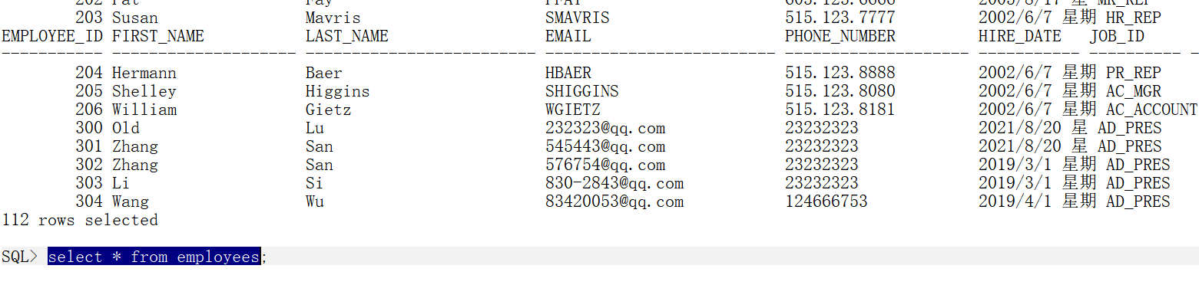
- 每个人的部门编号，姓名，薪水
select department_id,last_name,salary from employees;
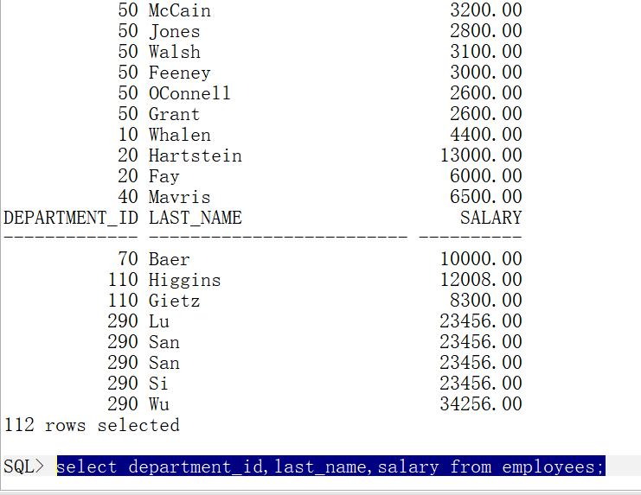
- 每个人的年薪
select last_name,12*salary from employees;
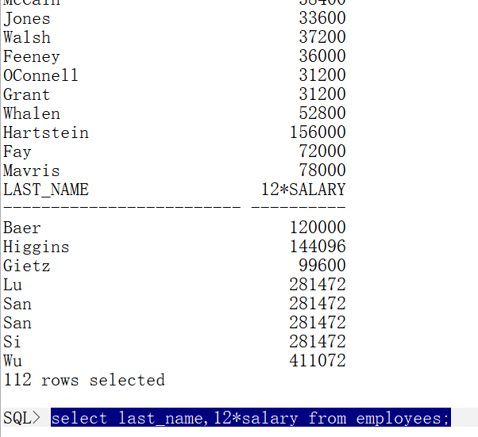
- 求每个人的年薪，列的别名：“年薪”
select last_name,12*salary "年薪" from employees;
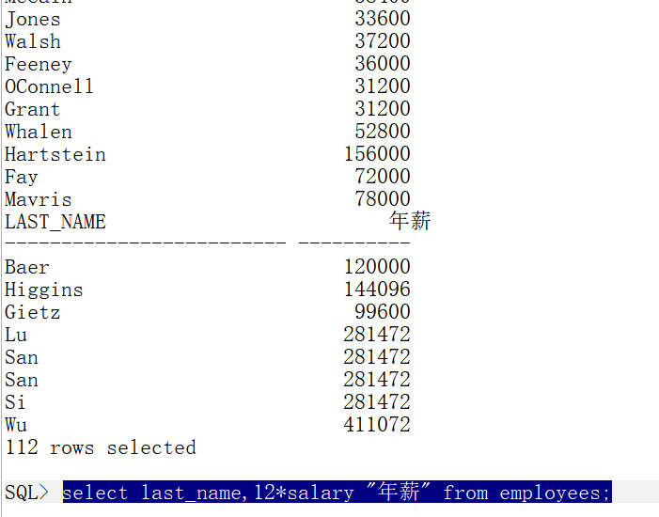
- 求 10 这个部门的所有员工
select * from employees where department_id = 10;
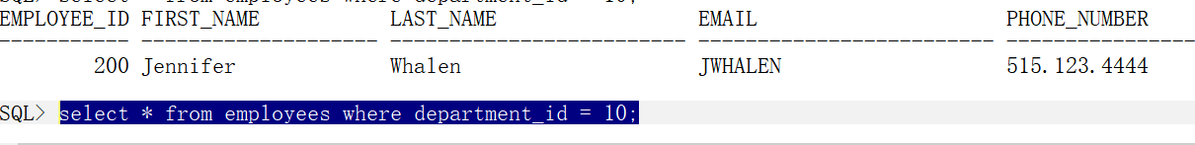
- 求名字是 KING 的这个人的信息
select * from employees where upper(last_name) = 'KING';
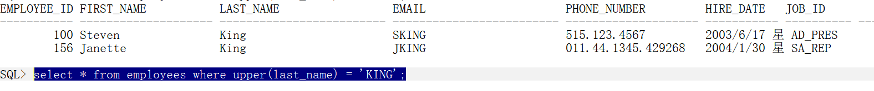
- 求薪水大于 2000 的员工信息
select * from employees where salary >2000;
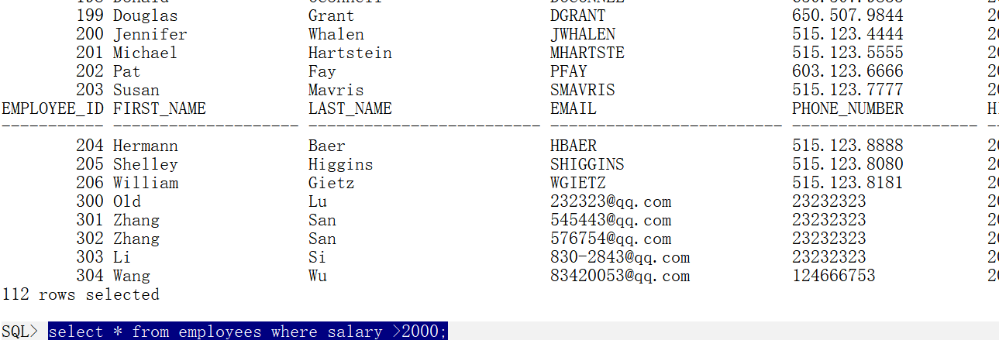
- 求部门不是 10 的员工信息
select * from employees where department_id <> 10;
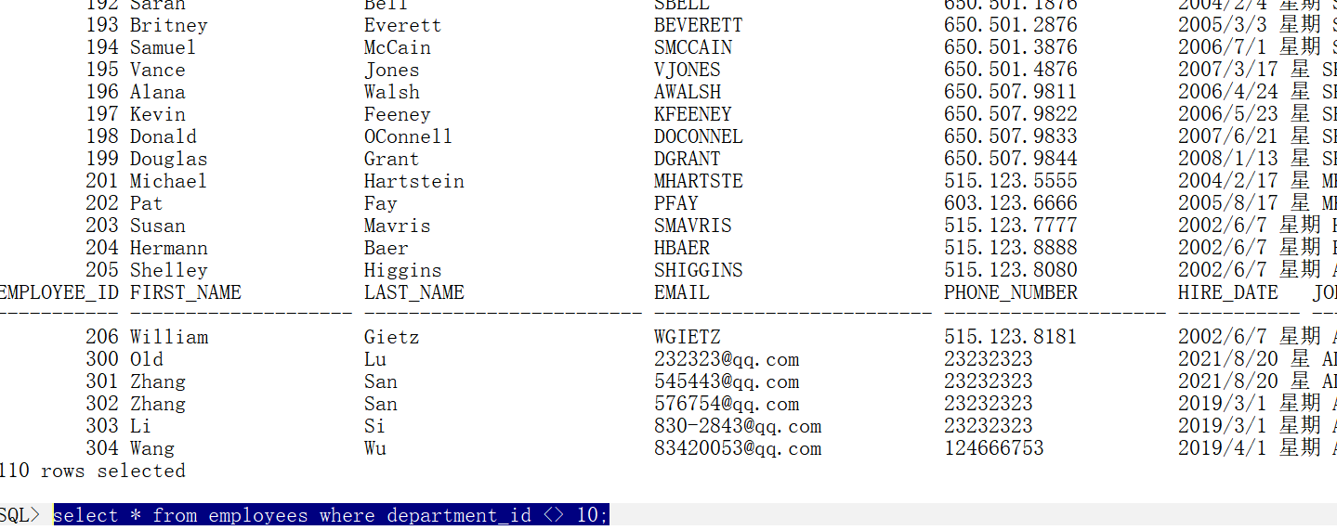
- 求薪水在 800 和 1500 之间的员工信息(包含 800 和 1500)
select * from employees where salary between 800 and 1500;
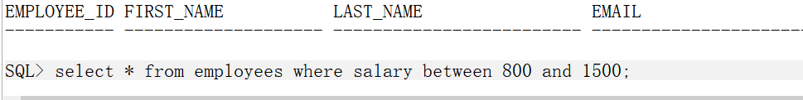
- 列出 deptno 为 10 或者 30，并且工资>2000 的所有人
select * from employees where department_id in(10,30) and salary >2000;
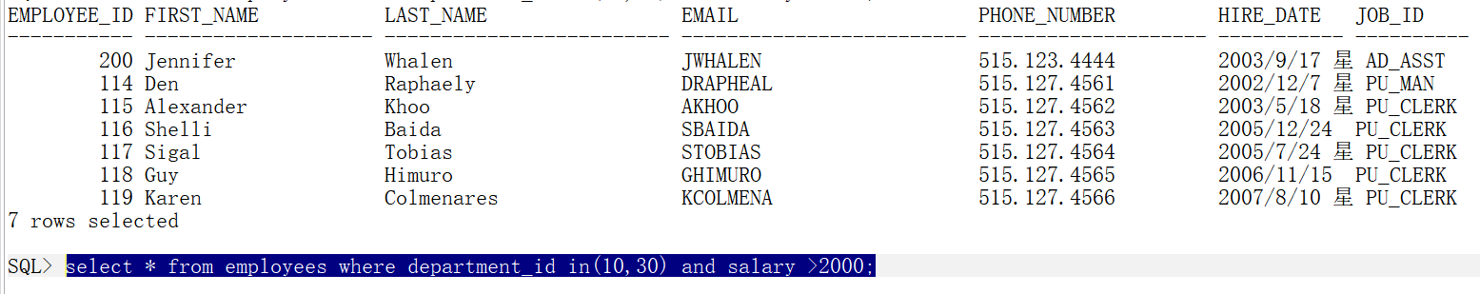
- 利用 in 操作符，列出部门 10 和 20 的人员
select * from employees where department_id in(10,20);
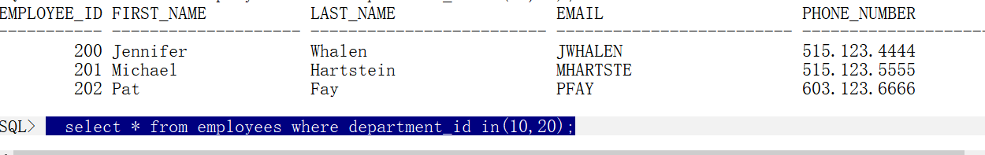
- 利用 like 操作符，查处名字中含有"H"的人员
select * from employees where last_name like '%H%';
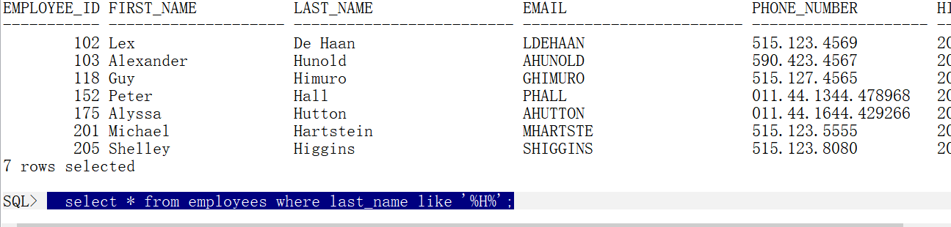
- 分别利用 like 操作符和正则表达式，查处名字中含有"S"或者"M"的人员
like:
select * from employees where last_name like '%S%' or last_name like '%M%';
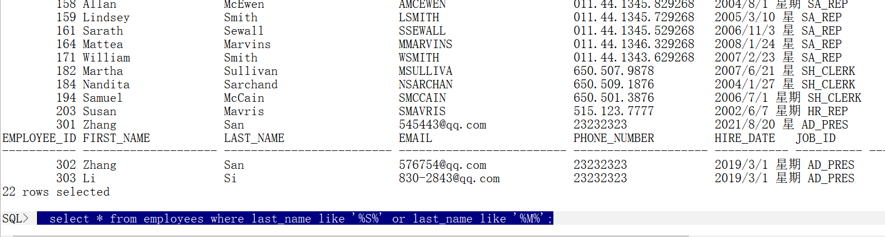
正则表达式 不会在SQLPL Developer中写正则表达式
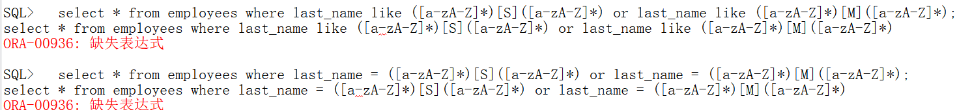
- 计算 emp 表中的所有人员的平均薪水
select avg(salary) from employees;
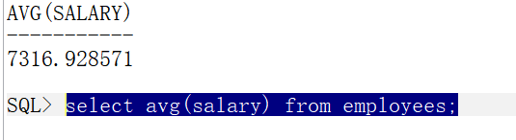
- 计算 emp 表中最高薪水
select max(salary) from employees;
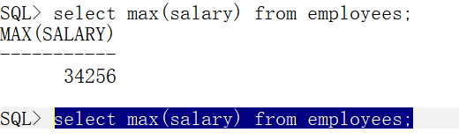
- 计算 emp 表中最低薪水
select min(salary) from employees;
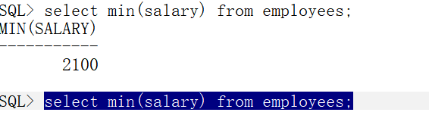
- 计算 emp 表中薪水大于 1000 的人员的个数
select count(*) from employees where salary >1000;
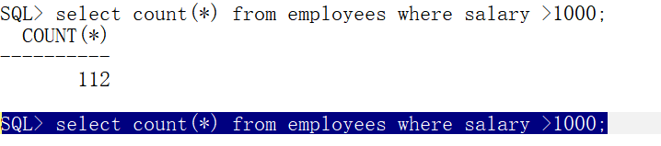

- 计算 emp 表中薪水的总和
select sum(salary) from employees;
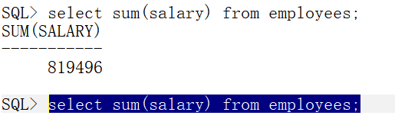
- 计算 emp 表中薪水和津贴的总和
select sum(salary+salary*nvl(commission_pct,0)) from employees;
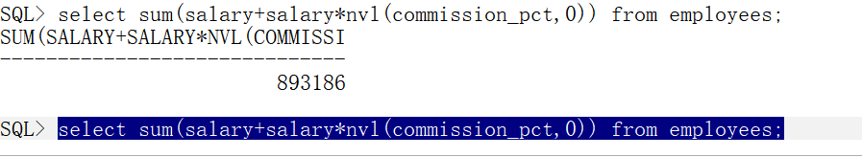
- 求各部门最高薪水
select department_id,max(salary) from employees group by department_id;
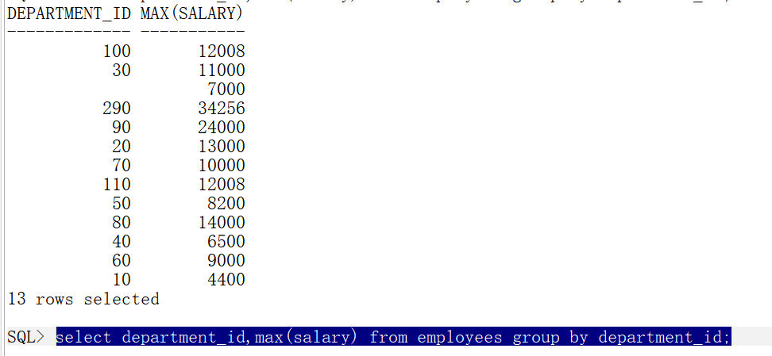
- 按照部门和职位分组，分别求最高薪水，该组人员个数
select department_id,job_id,max(salary),count(job_id),count(department_id) from employees group by department_id,job_id;
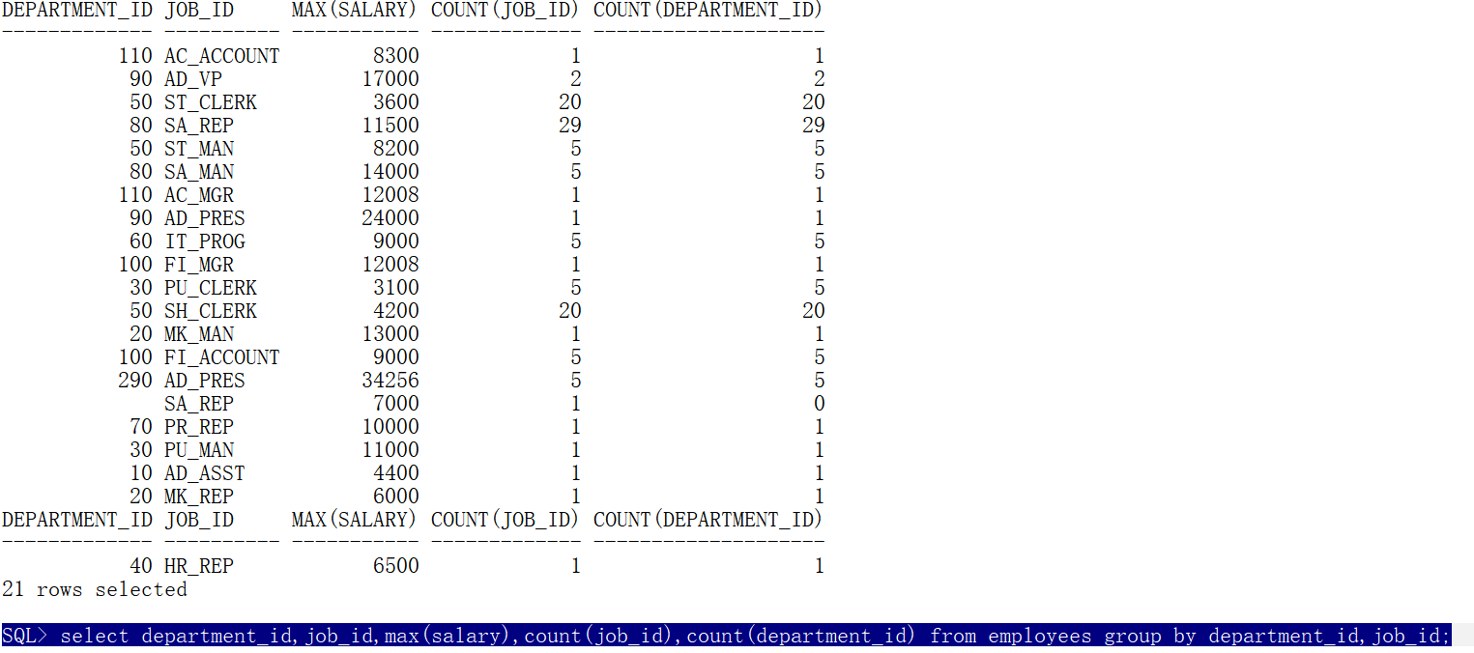
- 求薪水最高的员工姓名
select last_name from employees where salary = (select max(salary) from employees);
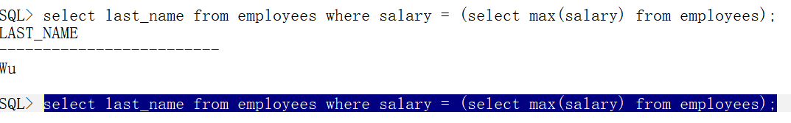
- 求平均薪水是 2000 以上的部门
select department_id,avg(salary) from employees group by department_id having avg(salary) >2000;
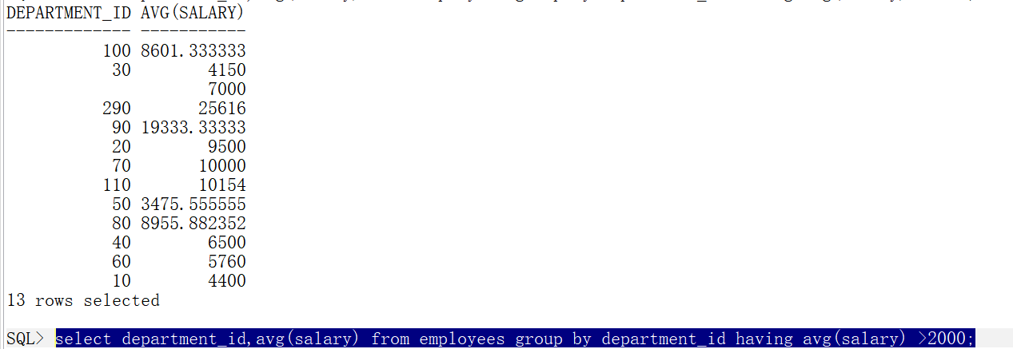
- 求每个部门的平均薪水，并按照薪水降序排列
select department_id,avg(salary) from employees group by department_id order by avg(salary) desc;
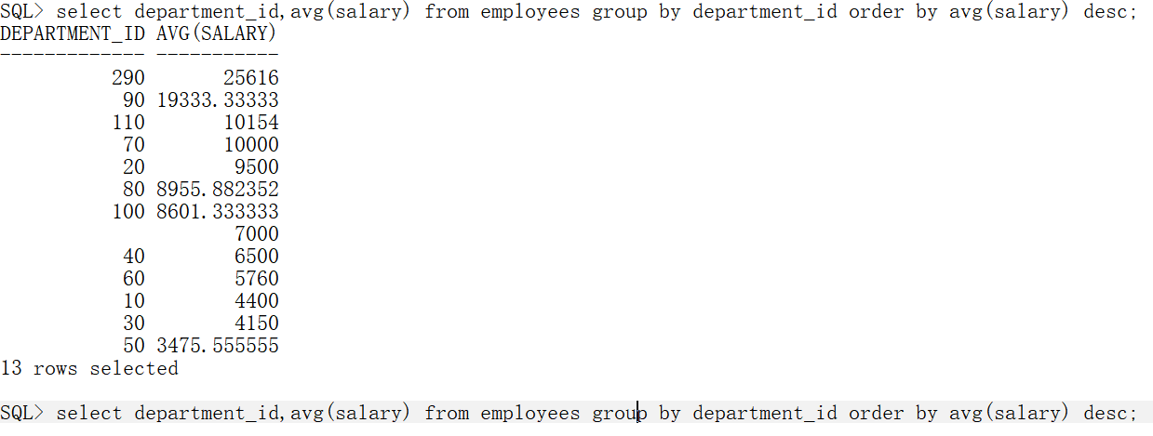

25. 求每个部门薪水在 1200 以上的雇员的平均薪水、最高薪水，并且分组结果
中只包含平均薪水大于 1500 的部门，排序按照部门平均薪水倒序排列
select department_id,avg(salary),max(salary) from employees where salary>1200 group by department_id having avg(salary) >1500 order by avg(salary) desc;
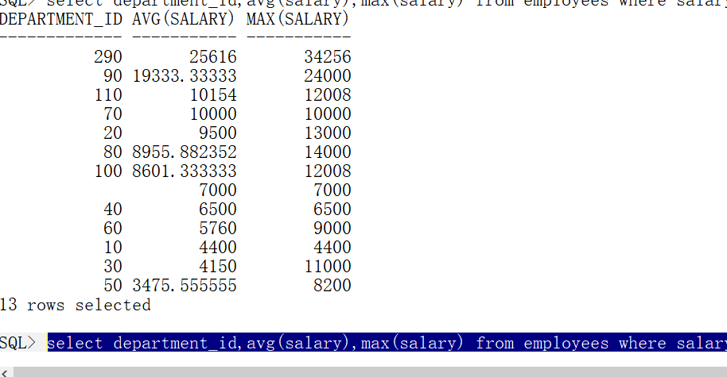
26.把雇员按部门分组， 求最高薪水， 部门号， 过滤掉名字中第二个字母是'A'的， 要求分组后的平均薪水>1500， 按照部门编号倒序排列
select max(salary),department_id from employees where last_name not like '_A%' group by department_id having avg(salary)>1500 order by department_id desc;
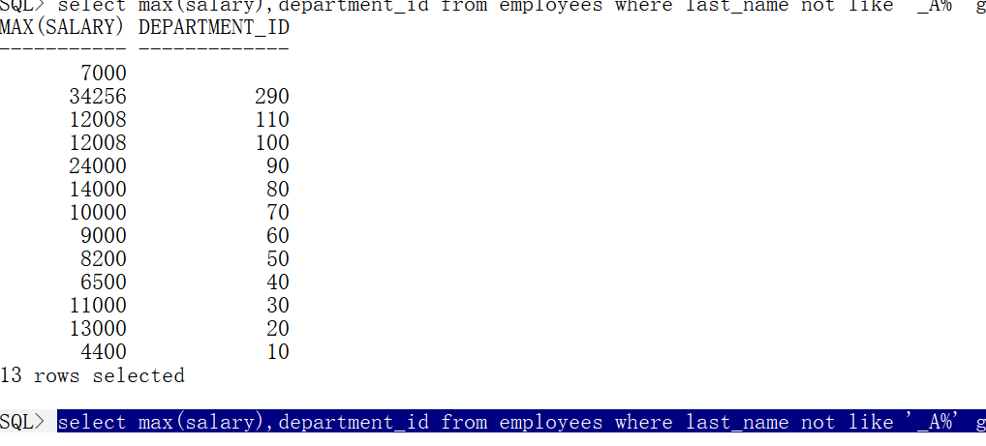

- 求平均薪水最高的部门的部门编号
select department_id from employees group by department_id having avg(salary) = (select max(avg(salary)) from employees group by department_id);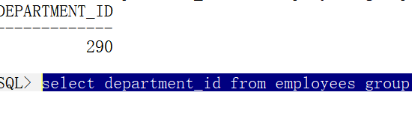
- 求出 emp 表中哪些人是经理人，打印出名字和编号
select distinct m.employee_id,m.last_name from employees e,employees m where e.manager_id = m.employee_id;
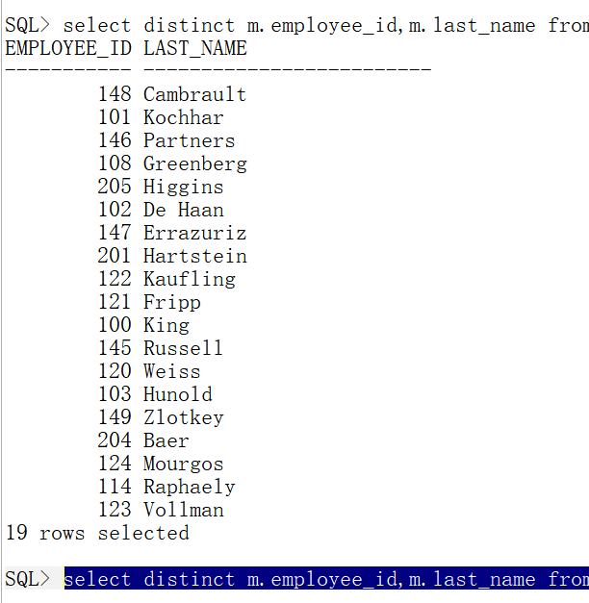
- 求比普通员工的最高薪水还要高的经理人名称
select distinct em.last_name from employees em where em.salary>(select max(e.salary) from employees e,employees em where e.manager_id = em.employee_id);
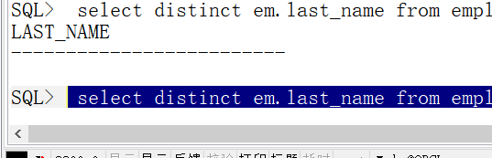
- 每个部门平均薪水的等级(需要用到表的连接)
select e.dep,e.al,j.gra from(select department_id dep,avg(salary) al from employees group by department_id) e,job_grades j where e.al between j.lowest_sal and j.highest_sal;
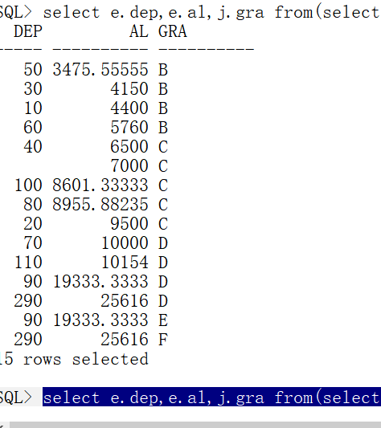

- 求部门经理人中平均薪水最低的部门名称
select rownum,department_id from(select m.department_id from employees e,employees m where e.manager_id = m.employee_id group by m.department_id order by avg(m.salary) ) where rownum = 1;
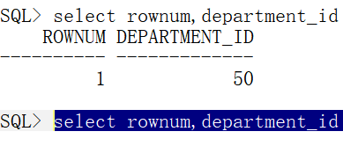
- 求薪水最高的前 5 名雇员
select rownum,last_name,salary from (select last_name,salary from employees order by salary desc) where rownum <6;
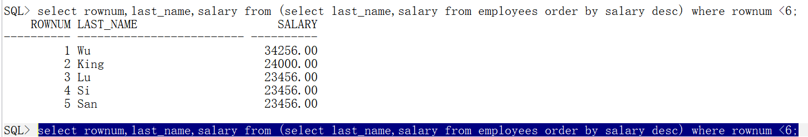
33. 求薪水最高的第 6 到第 10 名雇员
select * from(select rownum rw,last_name,salary from (select last_name,salary from employees order by salary desc )) e where e.rw between 6 and 10;
